## Merchant Name: Luxury Presence Implementation POC: Jeff *(IM to fill)* CX POC: *[IMP to Add]*

### 

### 

| Notes Sections   *(AE to fill if they have, Implementation to be completion DRI on handoff)*   * Info on how merchant bills   Only flat fee billing - choosing from a few different plans but change orders halfway through are common  1) What is the merchant temperament?  Alex - controller, very tech forward, trusting in AI, implementing us and Rillet at the same time. Really cool and nice guy. Funny  Chontel - Accounting manager - much more in the weeds, collections. Also very nice  Stefan - assistant controller - cool guy but new so i dont know him well  Carrie - sys admin - also new  3) What are the Tabs features that the key POC cares about?  [LP SOW](https://docs.google.com/document/d/18QstfT3Vm9KvpIVi0I0ojk228f4cWAT1/edit) |
| --- |

### Billing model *(Entire Section: Implementation to fill section)*

* Are there unique things about the customer creation process for this merchant?
* Information on how merchant bills
* How contract is broken up
* One off things to know about the merchant

### Contract Processing Steps *(Entire Section: Implementation/Success to fill Post-Go Live)*

1. Steps to process  
   **Two cases:**

* One-Time Fee = $0
* One-Time Fee <> $0

### One-Time Fee = $0

* If the one-time fee = 0, the first month’s fee in the subscription term will be charged when the contract is executed (date of last signature)

Billing Terms should be created as follows:

**Service start date:**

* use the subscription start date

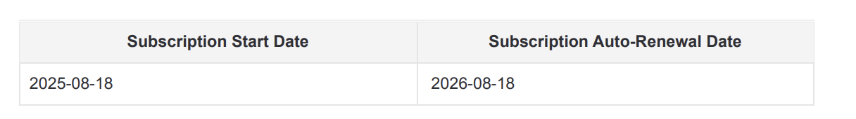

**Total months of service:**

* use the term noted in the billing terms

**Item Name:**

* use the name of the product (usually one-time fees or the item under plan name)

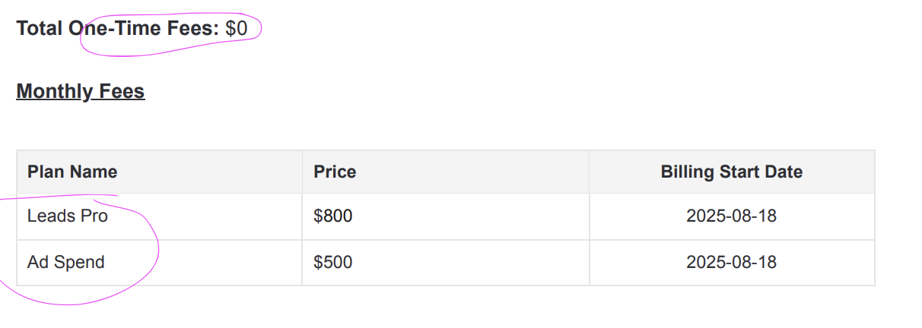

**Item Description:** n/a

**Integration Item:**

**Billing type:** flat

**Total price:** use the price listed for the product

**Quantity:** 1

**Billing start date:**

* One-time fees: last signature date
* First month fee: last signature date
* BT for the remaining service term: second month of the service term
  + E.g. if the “billing start date” in the contract is 8/18/25, the billing start date for this revenue schedule would be 9/18/25

**Number of periods:**

* One-time fees: 1
* First month fee: 1
* BT for the remaining service term: # of billing periods in the service term *minus* 1 (most likely 11 months)

**Frequency:**

* One-time fees: None
* First month fee: None
* BT for the remaining service term: check what the contract says (most likely month)

**Net terms:**

* 0

**Billing Timing:**

* Bill first of period

**ALSO!** Please create renewal BT as indicated in the billing terms and “Subscription Auto Renewal Date” column

### One-Time Fee <> $0

* If the one-time fee is **not** 0, it should be invoiced on the last signature date
* Monthly fees should start on the billing start date

**Service start date:**

* use the subscription start date

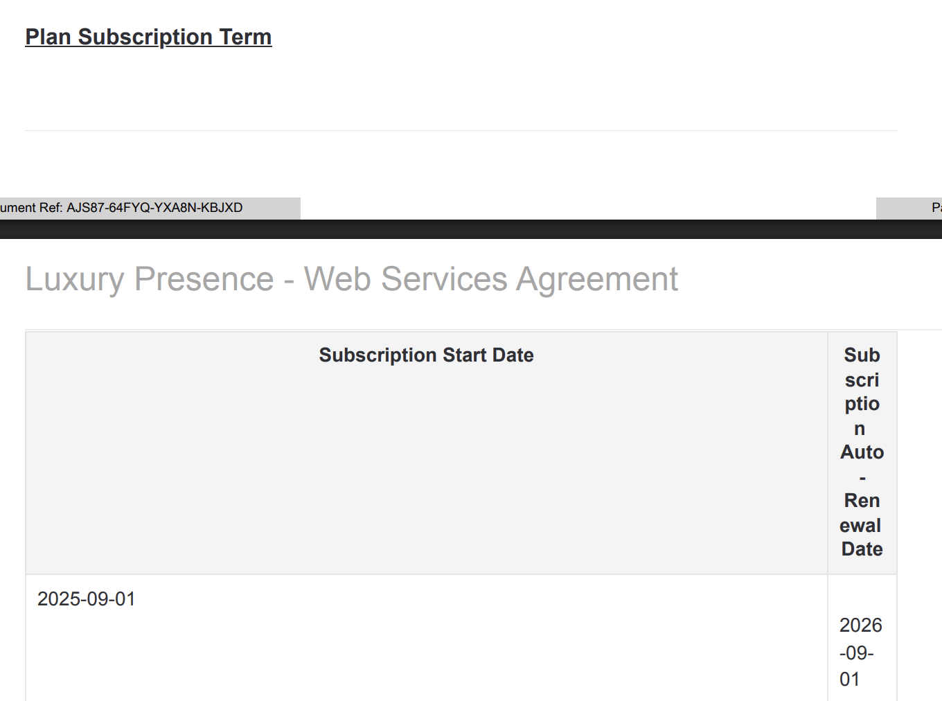

**Total months of service:**

* use the term noted in the billing terms

**Item Name:**

* use the name of the product (usually one-time fees or the item under plan name)



**Item Description:** n/a

**Integration Item:**

**Billing type:** flat

**Total price:** use the price listed for the product

**Quantity:** 1

**Billing start date:** use the billing start date

**Number of periods:** number of billing periods in the service term based on the frequency

* Example: If service term is a year and frequency = month, number of periods = 12
* Example: If service term is a year and frequency = 3 months, number of periods = 4

**Frequency:** check what the contract says; most likely a month

**Net terms:**

* 0

**Billing Timing:**

* Bill first of period

**ALSO!** Please create renewal BT as indicated in the billing terms and “Subscription Auto Renewal Date” column

**Examples**

1. Anything to ignore in contracts?
2. Specifics processing things the merchant has requested that may differ by contract (e.g. always back-date invoice date to final day of the month)
3. Default Service Term
   1. If None Listed, Ops Default is 1 Year
4. Default Net Payment Terms
   1. If None, Ops Default is 0
5. Default Billing Frequency
   1. If None Listed, Ops Default is Monthly
6. How do we handle taxes as a line item?
   1. If None Listed, Ops Default is every tax line item becomes a BT

### Events Processing (if necessary) *(Entire Section: Implementation/Success to fill Post-Go Live)*

* Any important information on events billing

Integration Items Processing (if necessary)  
*(Entire Section: Implementation/Success to fill Post-Go Live)*

* What are the instructions for assigning integration items?
* Example: All Statsig integrations items should be labeled as “Sales”
* Example: All “Pinata” integration items should be labeled as “Software Subscription Bundle” unless otherwise noted by Merchant

Post Processing Communications (if necessary)  
*(Entire Section: Implementation/Success to fill Post-Go Live)*

* Does the Ops Team need to notify anyone on the team re: completion of processing batches in Implementation or Active phase?
* Who needs to be notified and when?
  + Example:
    - Who: Customer Success [Azmat Aziz] needs to be notified
    - Where: Messari internal merchant channel
    - When: contracts are processed [Merchant Phase: Active]

### Customer Information *(Entire Section: Implementation/Success to fill Post-Go Live)*

* Any important information on specifics customers of this merchant
  + Special memo’s certain invoices require
  + Invoice changes due to merchant/customer relationship

### Feature Requests *(AE to fill for all requests prior to Imp handoff, Imp to fill prior to go-live/Success to fill to fill Post-Go Live)*

* FR 1
  + What is it
  + Why it's important
  + Urgency

### Merchant Calls *(AE to fill for all videos prior to Imp involvement, Imp to fill prior to go-live/Success to fill to fill Post-Go Live)*

* .
* .
* .